**LAPORAN UJIAN AKHIR SEMESTER**

**PRAKTIKUM PEMROGRAMAN WEB DINAMIS**

**Jarot Setiawan**

**L200190247**

**G**

**Database “guestbook.db”**

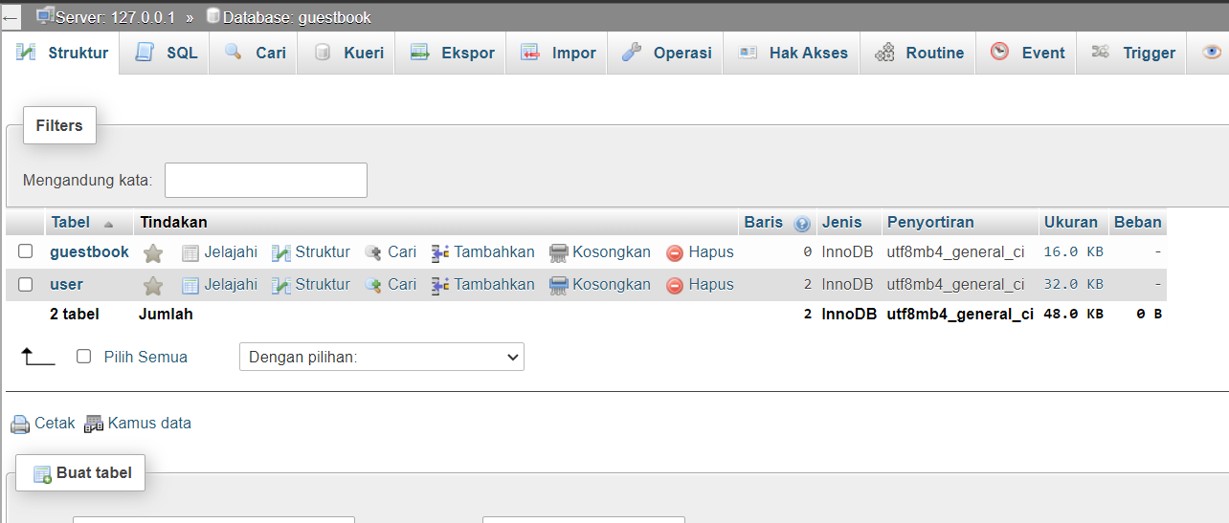

1. **User**

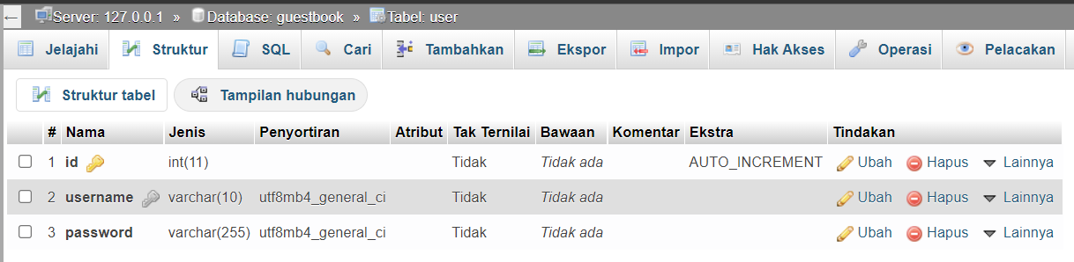

1. **Guestbook**

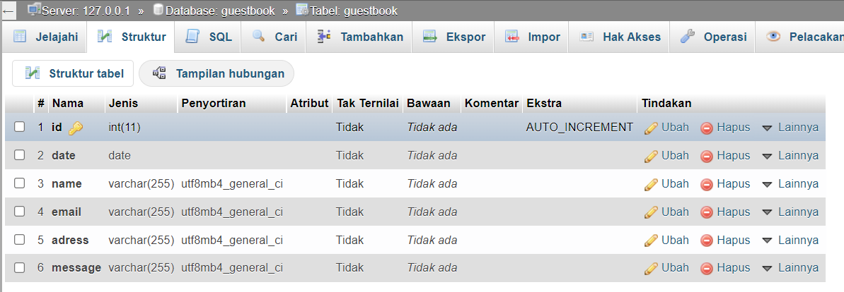

**Kode Php**

* **Login.php**
* <?php
* *require* "function.php";
* session_start();
* *if*(isset($_SESSION['username'])){
* *if*($_SESSION['username']== 'admin'){
* header("Location:admin.php");
* } *elseif*($_SESSION['username']== 'user'){
* header("Location:user.php");
* }
* }
* *if*(isset($_POST['login'])){
* $user = $_POST['username'];
* $password = $_POST['password'];
* cekAkun($user, $password);
* }
* *if*(isset($_POST['daftar'])){
* $user = $_POST['username'];
* $password = $_POST['password'];
* $confPass = $_POST['confpass'];
* daftar($user, $password, $confPass);
* }
* ?>
* <!DOCTYPE html>
* <html>
* <head>
* <title>Login / Register</title>
* <link href="https://cdn.jsdelivr.net/npm/bootstrap@5.1.3/dist/css/bootstrap.min.css" rel="stylesheet" integrity="sha384-1BmE4kWBq78iYhFldvKuhfTAU6auU8tT94WrHftjDbrCEXSU1oBoqyl2QvZ6jIW3" crossorigin="anonymous">
* </head>
* <body class="bg bg-secondary bg-opacity-10 d-flex align-items-center" style="width: 100vw; min-height: 100vh;">
* <div class="container">
* <h1 class="text-secondary fw-bold text-center my-5">Guestbook - Jarot Setiawan - L200190247</h1>
* <div class="row">
* <div class="col login bg-white rounded rounded-2 border border-end">
* <h3 class="text-center text-primary fw-bold mt-5 mb-3">Login</h3>
* <form action="" method="post" class="text-center mb-5">
* <p>Username</p>
* <input type="text" name="username" style="width: 50%;" required>
* <p>Password</p>
* <input type="password" name="password" style="width: 50%;" required>
* <br>
* <input type="submit" name="login" value="Login" class="bg-primary border-0 rounded rounded-3 text-white px-3 py-1 my-3">
* </form>
* </div>
* <div class="col register bg-white rounded rounded-2 border border-start">
* <h3 class="text-center text-primary fw-bold mt-5 mb-3">Register</h3>
* <form action="" method="post" class="text-center mb-5">
* <p>Username</p>
* <input type="text" name="username" style="width: 50%;" required>
* <p>Password</p>
* <input type="password" name="password" style="width: 50%;" required>
* <p>Konfirmasi Password</p>
* <input type="password" name="confpass" style="width: 50%;" required>
* <br>
* <input type="submit" name="daftar" value="Daftar" class="bg-primary border-0 rounded rounded-3 text-white px-3 py-1 my-3">
* </form>
* </div>
* </div>
* </div>
* </body>
* </html>
* **Index.php**
* <?php
* *require* "function.php";
* session_start();
* *if*($_SESSION['username'] != 'user'){
* echo "<script>alert('Silahkan login sebagai user')</script>";
* header("Location:login.php");
* }
* *if*(isset($_POST['kirim'])){
* $name = $_POST['name'];
* $email = $_POST['email'];
* $adress = $_POST['adress'];
* $message = $_POST['message'];
* $date = date('Y-m-d');
* tambah($name, $email, $adress, $message, $date);
* }
* ?>
* <!DOCTYPE html>
* <html>
* <head>
* <title>Guest Book Sign</title>
* <link href="https://cdn.jsdelivr.net/npm/bootstrap@5.1.3/dist/css/bootstrap.min.css" rel="stylesheet" integrity="sha384-1BmE4kWBq78iYhFldvKuhfTAU6auU8tT94WrHftjDbrCEXSU1oBoqyl2QvZ6jIW3" crossorigin="anonymous">
* </head>
* <body class="bg bg-secondary bg-opacity-10" style="width: 100vw; min-height: 100vh;">
* <h1 class="fw-light text-secondary text-center py-3">Guest Book Sign</h1>
* <div class="container">
* <a href="logout.php" class="text-end bg-danger rounded text-decoration-none text-white px-3 py-1" style="position: absolute;">Log Out</a>
* <div class="form-sign bg-white rounded border border-1">
* <h3 class="text-center text-primary fw-bold mt-5 mb-3">Test's GuestBook</h3>
* <p class="text-center text-secondary">Please sign my Guestbook!</p>
* <form action="" method="post" class="bg-primary bg-opacity-10 my-2 py-4 mx-5 px-5" style="border-radius: 20px;">
* <p>Nama Lengkap <span class="text-danger">*</span> </p>
* <input type="text" name="name" maxlength="255" required style="width: 100%;">
* <p>Email</p>
* <input type="email" name="email" maxlength="255" style="width: 100%;">
* <p>Alamat</p>
* <input type="text" name="adress" maxlength="255" style="width: 100%;">
* <p>Pesan <span class="text-danger">*</span></p>
* <textarea name="message" required style="width: 100%; height: 100px;">
* </textarea>
* <div class="button text-center my-2">
* <input type="submit" name="kirim" value="Kirim" class="border-0 rounded rounded-3 bg-primary text-white py-1 px-3">
* </div>
* </form>
* <hr>
* <div class="sign-guestbook">
* <?php
* $data_sign = query("select * from guestbook");
* ?>
* <?php *if*(count($data_sign)>0): ?>
* <p class="text-center text-secondary">Total Entries : (<?= count($data_sign) ?>)</p>
* <?php *foreach*($data_sign as $row): ?>
* <div class="bg-primary bg-opacity-10 my-2 py-4 mx-5 px-5" style="border-radius: 20px;">
* <div class="row">
* <div class="col">
* <div class="row">
* <div class="col-3">
* <p>Siapa Namamu? </p>
* <p>Darimana kamu berasal?</p>
* <p class="mb-0">Pesanmu</p>
* </div>
* <div class="col text-start">
* <p class="fw-bold"><?= $row['name'] ?></p>
* <p><?= $row['adress'] ?></p>
* <p class="mb-0"><?= $row['message'] ?></p>
* </div>
* </div>
* </div>
* <div class="col-2 text-end">
* <p class="my-0"><?= $row['date'] ?></p>
* </div>
* </div>
* </div>
* <?php *endforeach* ?>
* <?php *endif* ?>
* </div>
* </div>
* </div>
* </body>
* </html>
* **Admin.php**
* <?php
* *require* "function.php";
* session_start();
* *if*($_SESSION['username'] != 'admin'){
* echo "<script>alert('Silahkan login sebagai admin')</script>";
* header("Location:login.php");
* }
* *if*(isset($_POST['hapus'])){
* $id = $_POST['id'];
* hapus($id, 'guestbook');
* }
* *if*(isset($_POST['edit'])){
* $id = $_POST['id'];
* edit($id);
* }
* ?>
* <!DOCTYPE html>
* <html>
* <head>
* <title>Document</title>
* *<!-- Link Bootstarp -->*
* <link href="https://cdn.jsdelivr.net/npm/bootstrap@5.1.3/dist/css/bootstrap.min.css" rel="stylesheet" integrity="sha384-1BmE4kWBq78iYhFldvKuhfTAU6auU8tT94WrHftjDbrCEXSU1oBoqyl2QvZ6jIW3" crossorigin="anonymous">
* </head>
* <body style="width: 100vw; min-height: 100vh;" class="bg-secondary bg-opacity-10">
* <h1 class="text-center text-secondary fw-light py-3">Guestbook Post</h1>
* <div class="container">
* <a href="logout.php" class="text-end bg-danger rounded text-decoration-none text-white px-3 py-1">Log Out</a>
* <div class="post bg-white rounded border border-1">
* <div class="item p-3">
* <?php
* $data_post = query("select * from guestbook");
* ?>
* <div class="row border-top border-bottom">
* <div class="col-8 fw-bold text-secondary">
* Author / Post
* </div>
* <div class="col-2 fw-bold text-center text-secondary">Tanggal</div>
* <div class="col-2"></div>
* </div>
* <?php *if*(count($data_post)>0): ?>
* <?php *foreach*($data_post as $row): ?>
* <div class="row border-bottom">
* <div class="col-8">
* <div class="row">
* <div class="col fw-bold">
* <?= $row['name'] ?>
* </div>
* </div>
* <div class="row">
* <div class="col">
* <?= $row['email'] ?>
* <br>
* <?= $row['message'] ?>
* </div>
* </div>
* </div>
* <div class="col-2 d-flex align-items-center text-center justify-content-center">
* <?= $row['date'] ?>
* </div>
* <div class="col-2 d-flex align-items-center justify-content-around">
* <form method="post">
* <input type="submit" name="edit" value="Edit" class="bg-primary border-0 rounded rounded-3 text-white px-3 py-1">
* <input type="submit" name="hapus" value="Hapus" class="bg-danger border-0 rounded rounded-3 text-white px-3 py-1">
* <input type="hidden" name="id" value="<?= $row['id'] ?>">
* </form>
* </div>
* </div>
* <?php *endforeach* ?>
* <?php *endif* ?>
* </div>
* </div>
* </div>
* </body>
* </html>
* **Edit.php**
* <?php
* *require* "function.php";
* session_start();
* *if*($_SESSION['username'] != 'admin'){
* echo "<script>alert('Silahkan login sebagai admin')</script>";
* header("Location:login.php");
* }
* *if*(!isset($_GET['id'])){
* header("Location:login.php");
* } *else* {
* $id = $_GET['id'];
* }
* *if*(isset($_POST['edit'])){
* $name = $_POST['name'];
* $email = $_POST['email'];
* $adress = $_POST['adress'];
* $message = $_POST['message'];
* $query_edit = "update guestbook set name='$name', email='$email', adress='$adress', message='$message' where id='$id'";
* *if*(!mysqli_query($conn, $query_edit)){
* echo mysqli_error($conn);
* } *else* {
* echo "<script>alert('Berhasil Diedit')</script>";
* header("Location:admin.php");
* }
* }
* ?>
* <!DOCTYPE html>
* <html>
* <head>
* <title>Guest Book Sign</title>
* <link href="https://cdn.jsdelivr.net/npm/bootstrap@5.1.3/dist/css/bootstrap.min.css" rel="stylesheet" integrity="sha384-1BmE4kWBq78iYhFldvKuhfTAU6auU8tT94WrHftjDbrCEXSU1oBoqyl2QvZ6jIW3" crossorigin="anonymous">
* </head>
* <body class="bg bg-secondary bg-opacity-10" style="width: 100vw; min-height: 100vh;">
* <h1 class="fw-light text-secondary text-center py-3">Guest Book Edit</h1>
* <div class="container">
* <div class="form-sign bg-white rounded border border-1">
* <?php
* $data_edit = query("select * from guestbook where id='$id'");
* *if*(count($data_edit)==0){
* header("Location:login.php");
* }
* ?>
* <form action="" method="post" class="bg-primary bg-opacity-10 my-2 py-4 mx-5 px-5" style="border-radius: 20px;">
* <p>Nama Lengkap <span class="text-danger">*</span> </p>
* <input type="text" name="name" maxlength="255" required value="<?= $data_edit[0]['name'] ?>" style="width: 100%;">
* <p>Email</p>
* <input type="email" name="email" maxlength="255" required value="<?= $data_edit[0]['email'] ?>" style="width: 100%;">
* <p>Alamat</p>
* <input type="text" name="adress" maxlength="255" required value="<?= $data_edit[0]['adress'] ?>" style="width: 100%;">
* <p>Pesan <span class="text-danger">*</span></p>
* <textarea name="message" required style="width: 100%; height: 100px;"><?= $data_edit[0]['message'] ?></textarea>
* <div class="button text-center my-2">
* <input type="submit" name="edit" value="Edit" class="border-0 rounded rounded-3 bg-primary text-white py-1 px-3">
* </div>
* </form>
* </div>
* </div>
* </body>
* </html>
* **Logut.php**
* <?php
* session_start();
* $_SESSION=[];
* $_SESSION['username'] = null;
* session_unset();
* session_destroy();
* header("Location:login.php");
* ?>
* **Function.php**
* <?php
* $conn = mysqli_connect('localhost', 'root', '', 'guestbook');
* *function* query($query){
* global $conn;
* $data = mysqli_query($conn, $query);
* echo mysqli_error($conn);
* $rows = [];
* *while* ($row = mysqli_fetch_assoc($data)){
* $rows[] = $row;
* }
* *return* $rows;
* }
* *function* tambah($name, $email, $adress, $message, $date){
* global $conn;
* $query_insert = "insert into guestbook values (NULL, '$date', '$name', '$email', '$adress', '$message')";
* *if*(!mysqli_query($conn, $query_insert)){
* echo mysqli_error($conn);
* } *else* {
* echo "<script>alert('Berhasil Terkirim')</script>";
* }
* }
* *function* cekAkun($user, $pass){
* global $conn;
* $akun = query("select * from user where username='$user'");
* *if* (mysqli_affected_rows($conn)){
* *if*($akun[0]['username']==$user && $akun[0]['password']==$pass){
* *if*($user == 'admin'){
* $_SESSION['username'] = 'admin';
* header("Location:admin.php");
* } *else* {
* $_SESSION['username'] = 'user';
* header("Location:index.php");
* }
* *return* true;
* } *else* {
* *return* false;
* }
* }
* var_dump(mysqli_error($conn));
* }
* *function* daftar($user, $pass, $confPass){
* global $conn;
* *if*($pass != $confPass){
* echo "<script>alert('Password dan Konfirmasi Password harus sama!')</script>";
* *return* false;
* }
* $dataUser = query("select * from user where username='$user'");
* *if*(count($dataUser)>0){
* echo "<script>alert('Username sudah terpakai')</script>";
* *return* false;
* }
* $query_insert = "insert into user (id, username, password) values (NULL, '$user', '$pass')";
* *if*(!mysqli_query($conn, $query_insert)){
* echo mysqli_error($conn);
* } *else* {
* echo "<script>alert('Berhasil Terdaftar')</script>";
* }
* }
* *function* hapus($id, $tabel){
* global $conn;
* $query_delete = "delete from $tabel where id='$id'";
* *if*(!mysqli_query($conn, $query_delete)){
* echo mysqli_error($conn);
* } *else* {
* echo "<script>alert('Berhasil Terhapus')</script>";
* }
* }
* *function* edit($id){
* header("Location:edit.php?id=$id");
* }
* ?>

**Penjelasan Function php**

* **Koneksi db**

$conn = mysqli_connect('localhost', 'root', '', 'guestbook');

* **Get data hasil query**

*function* query($query){

        global $conn;

        $data = mysqli_query($conn, $query);

        echo mysqli_error($conn);

        $rows = [];

*while* ($row = mysqli_fetch_assoc($data)){

            $rows[] = $row;

        }

*return* $rows;

    }

* **Menambah data guestbook**

*function* tambah($name, $email, $adress, $message, $date){

        global $conn;

        $query_insert = "insert into guestbook values (NULL, '$date', '$name', '$email', '$adress', '$message')";

*if*(!mysqli_query($conn, $query_insert)){

            echo mysqli_error($conn);

        } *else* {

            echo "<script>alert('Berhasil Terkirim')</script>";

        }

    }

* **Cek Akun Login**

*function* cekAkun($user, $pass){

        global $conn;

        $akun = query("select * from user where username='$user'");

*if* (mysqli_affected_rows($conn)){

*if*($akun[0]['username']==$user && $akun[0]['password']==$pass){

*if*($user == 'admin'){

                    $_SESSION['username'] = 'admin';

                    header("Location:admin.php");

                } *else* {

                    $_SESSION['username'] = 'user';

                    header("Location:index.php");

                }

*return* true;

            } *else* {

*return* false;

            }

        }

        var_dump(mysqli_error($conn));

    }

* **Daftar Akun**

*function* daftar($user, $pass, $confPass){

        global $conn;

*if*($pass != $confPass){

            echo "<script>alert('Password dan Konfirmasi Password harus sama!')</script>";

*return* false;

        }

        $dataUser = query("select * from user where username='$user'");

*if*(count($dataUser)>0){

            echo "<script>alert('Username sudah terpakai')</script>";

*return* false;

        }

        $query_insert = "insert into user (id, username, password) values (NULL, '$user', '$pass')";

*if*(!mysqli_query($conn, $query_insert)){

            echo mysqli_error($conn);

        } *else* {

            echo "<script>alert('Berhasil Terdaftar')</script>";

        }

    }

* **Hapus Item**

*function* hapus($id, $tabel){

        global $conn;

        $query_delete = "delete from $tabel where id='$id'";

*if*(!mysqli_query($conn, $query_delete)){

            echo mysqli_error($conn);

        } *else* {

            echo "<script>alert('Berhasil Terhapus')</script>";

        }

    }

* **Pindah edit**

*function* edit($id){

        header("Location:edit.php?id=$id");

    }

**Implementasi**

1. **Sign Up**

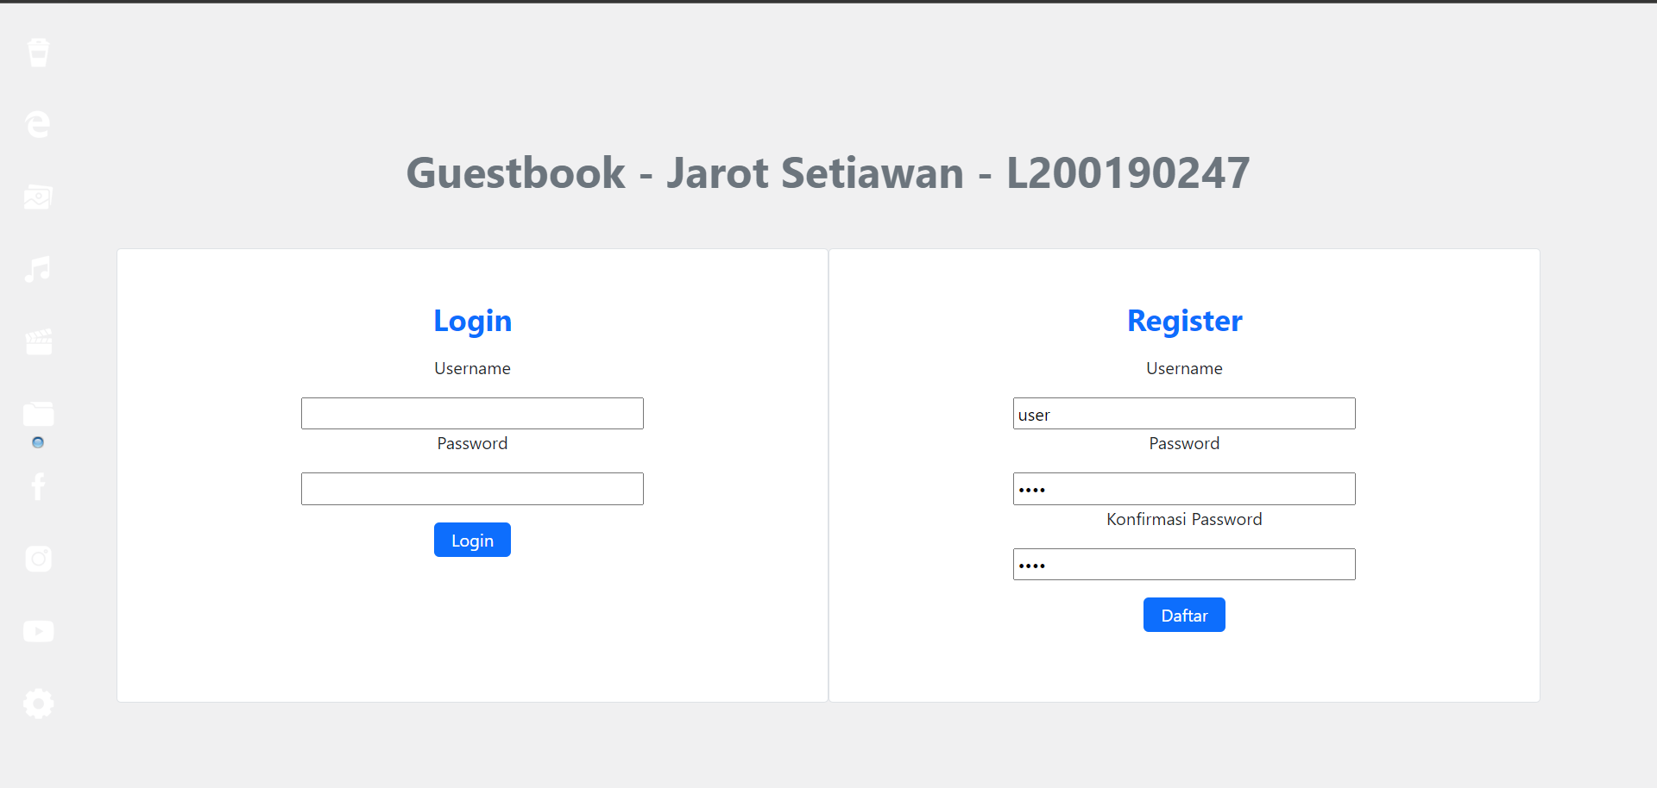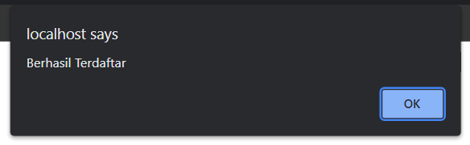

1. **Login > beranda**
   1. **user**

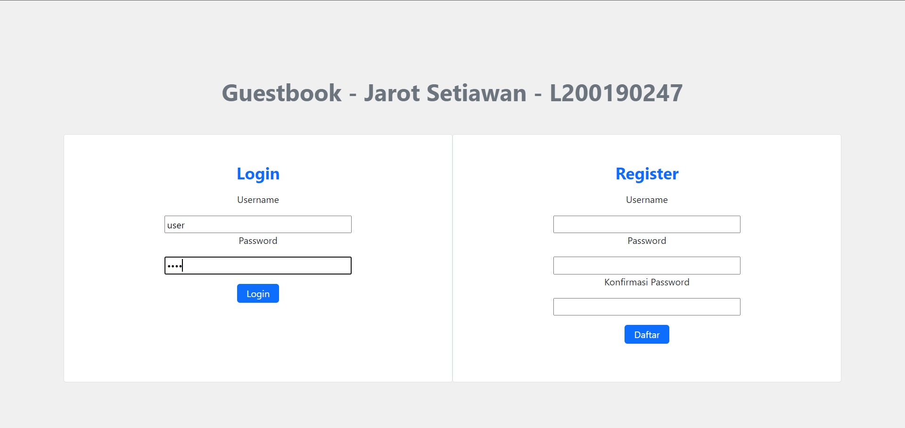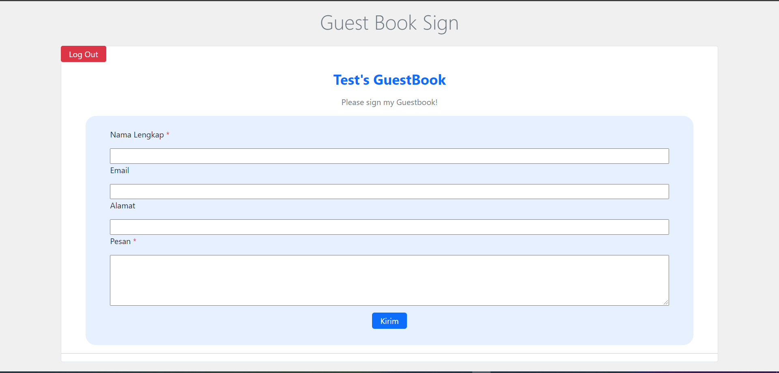

* 1. **admin**

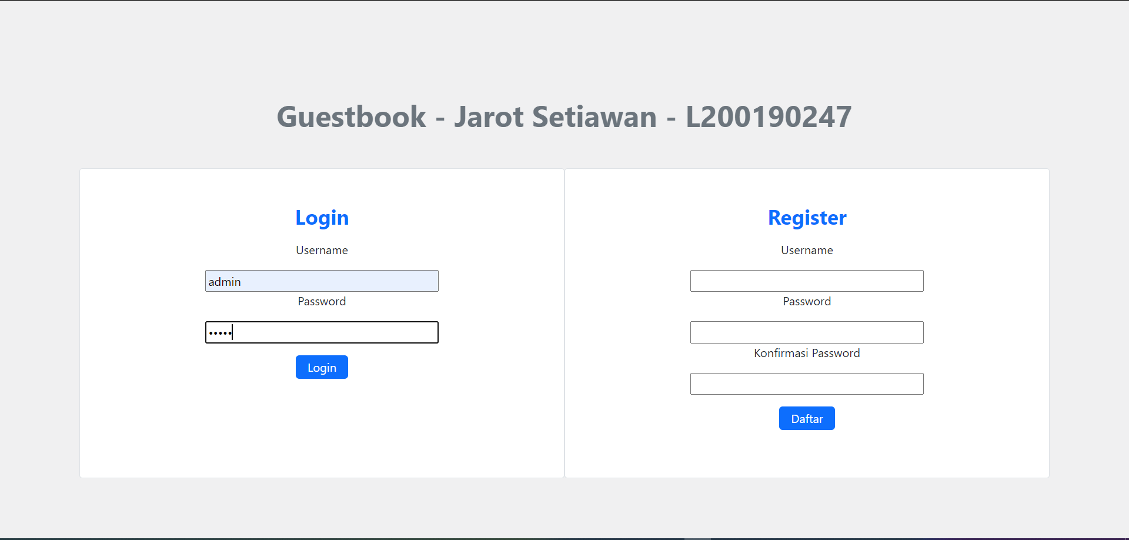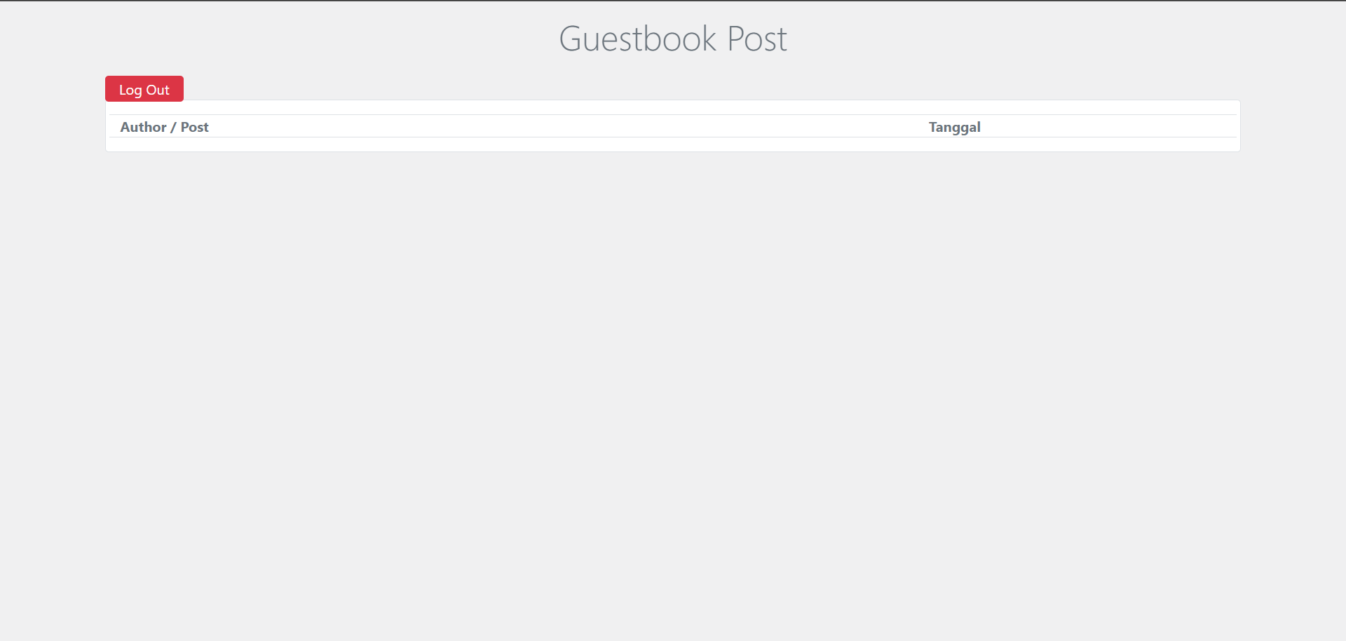

1. **Form Guestbook > input > view**

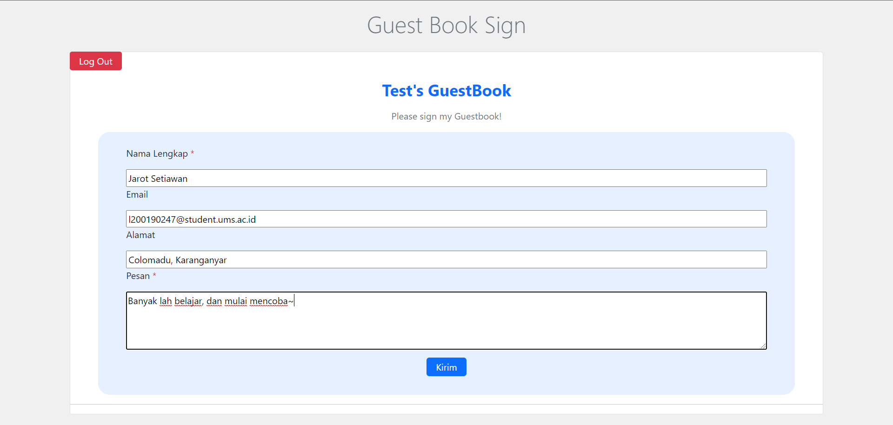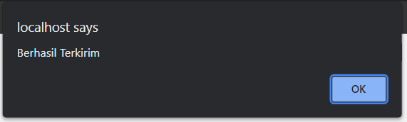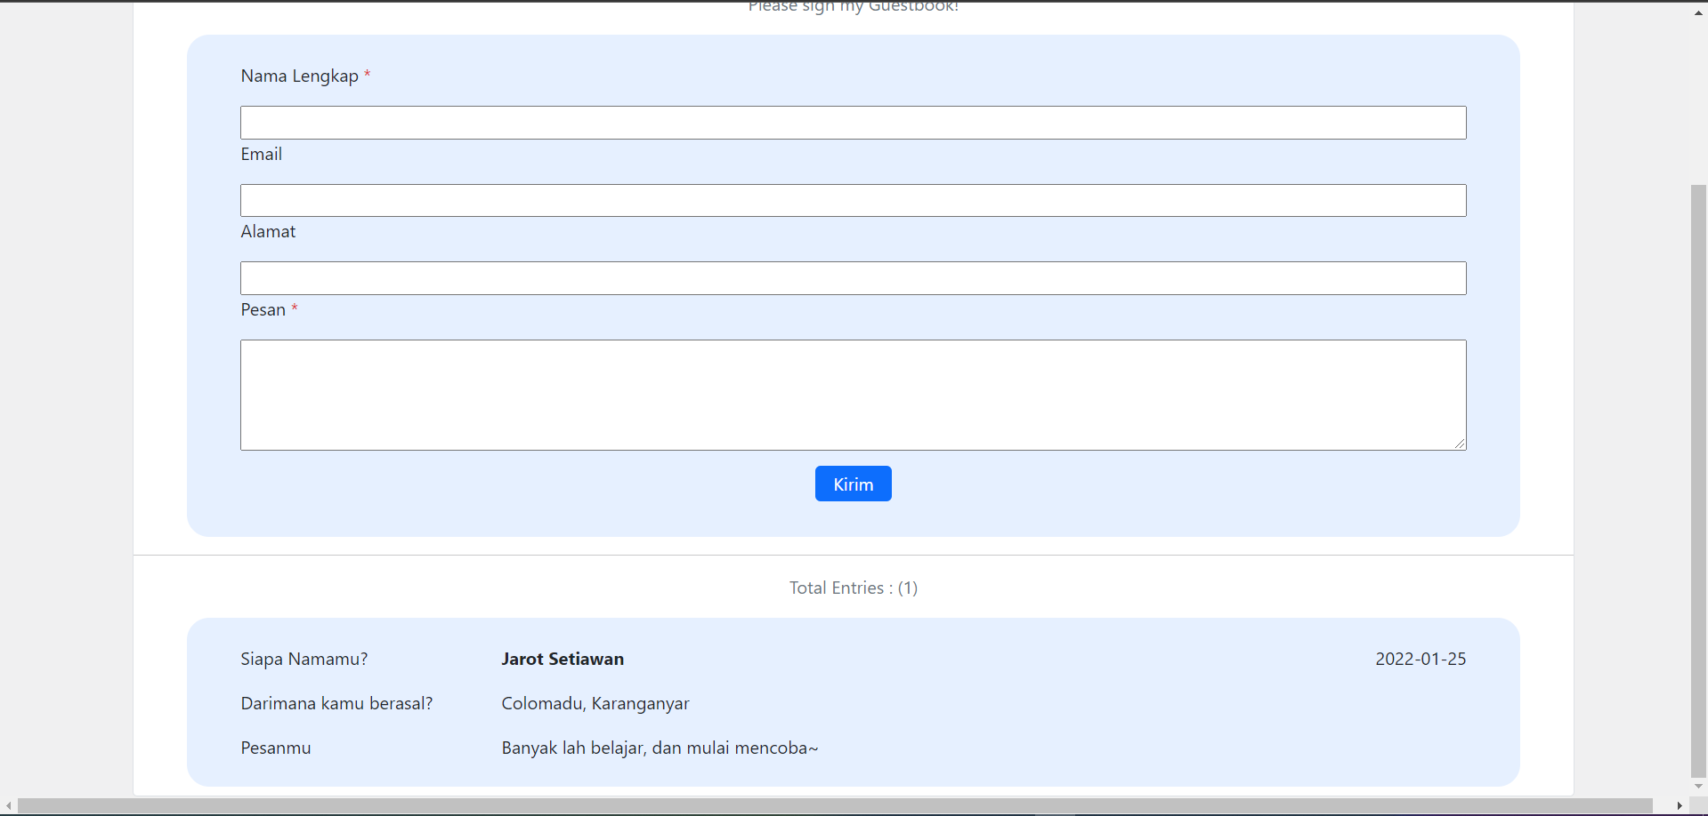

1. **Halaman admin menampilkan hasil**

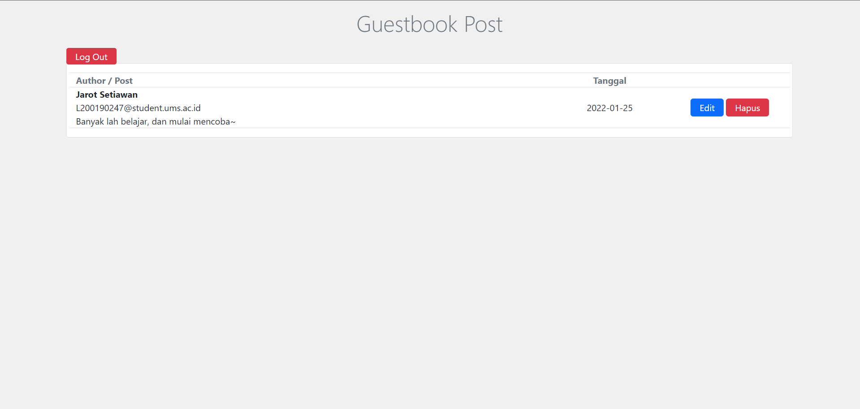

* **Edit**

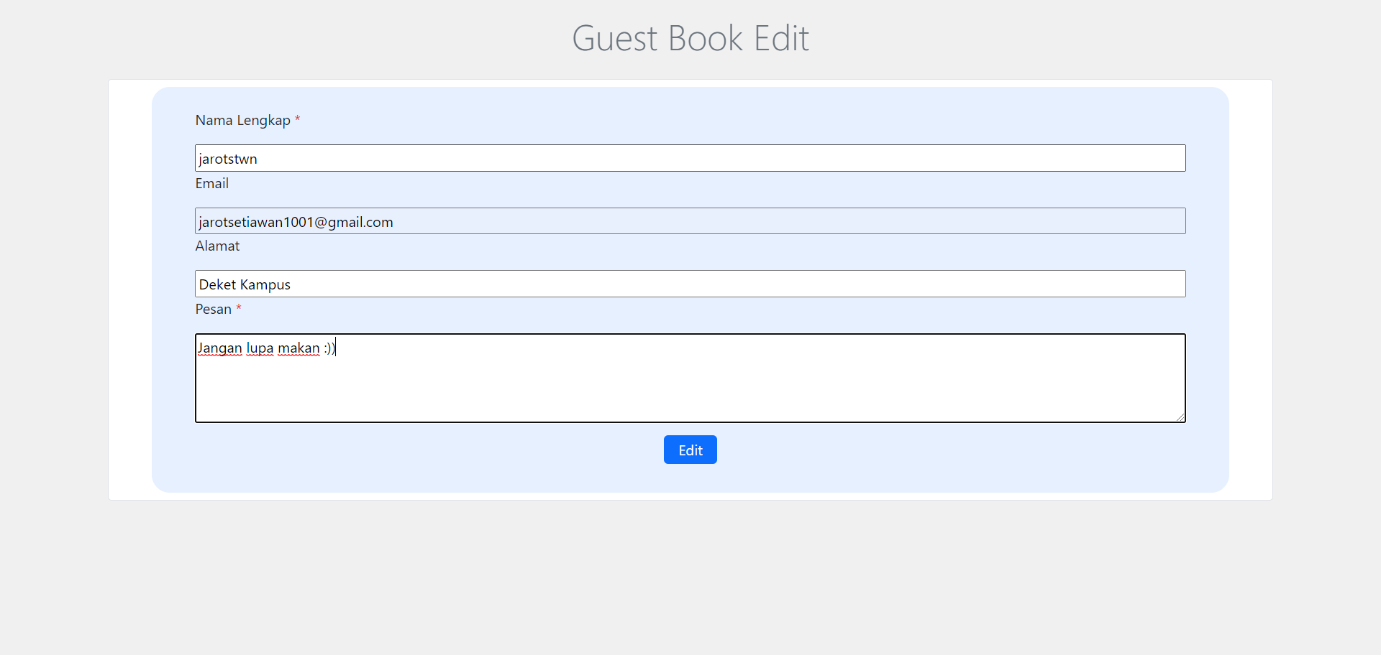

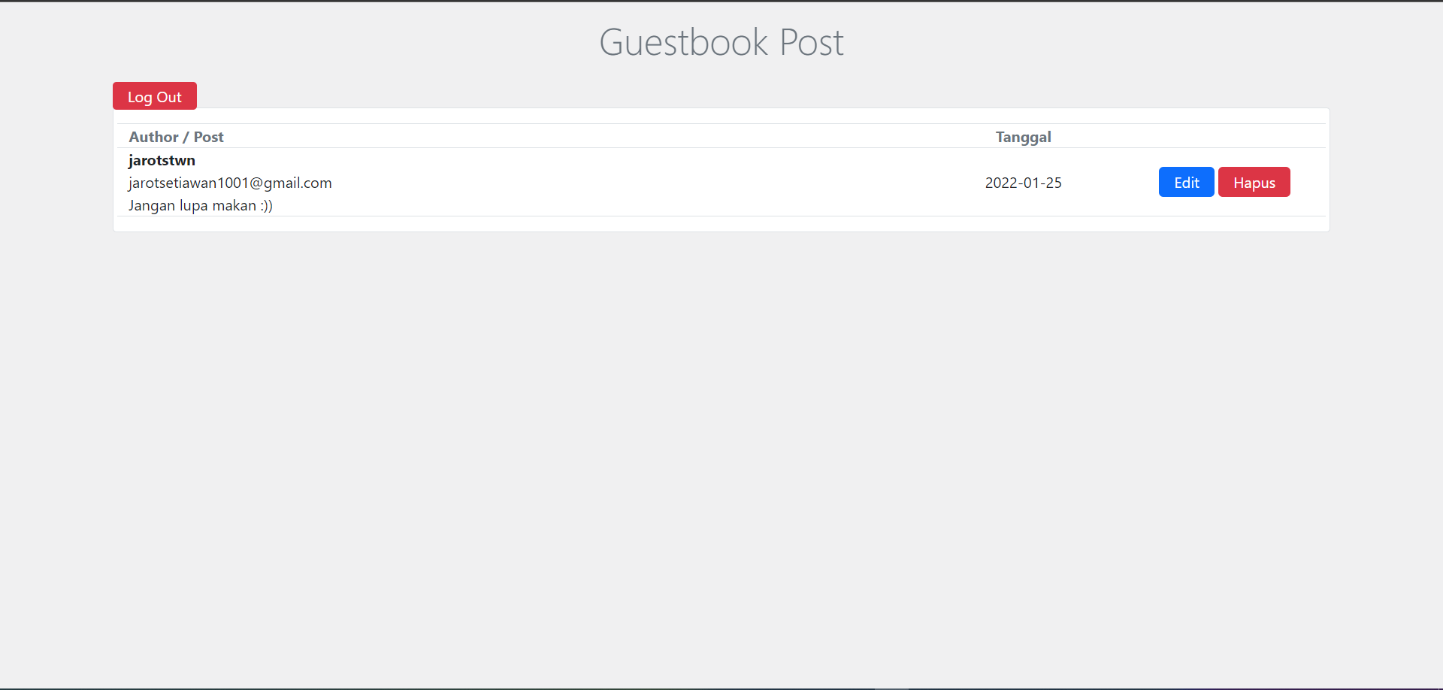

* **Delete guestbook**



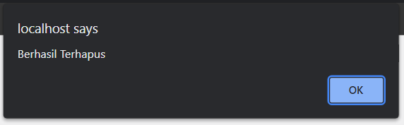

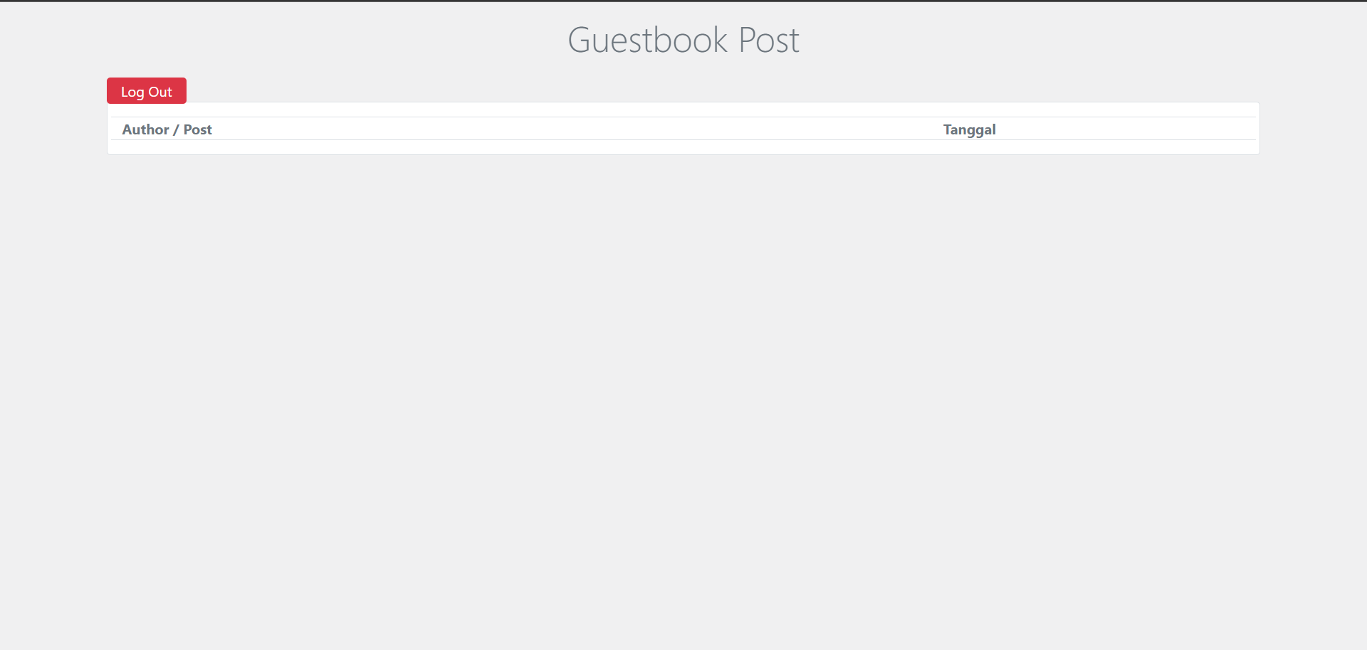

1. **Log ut**



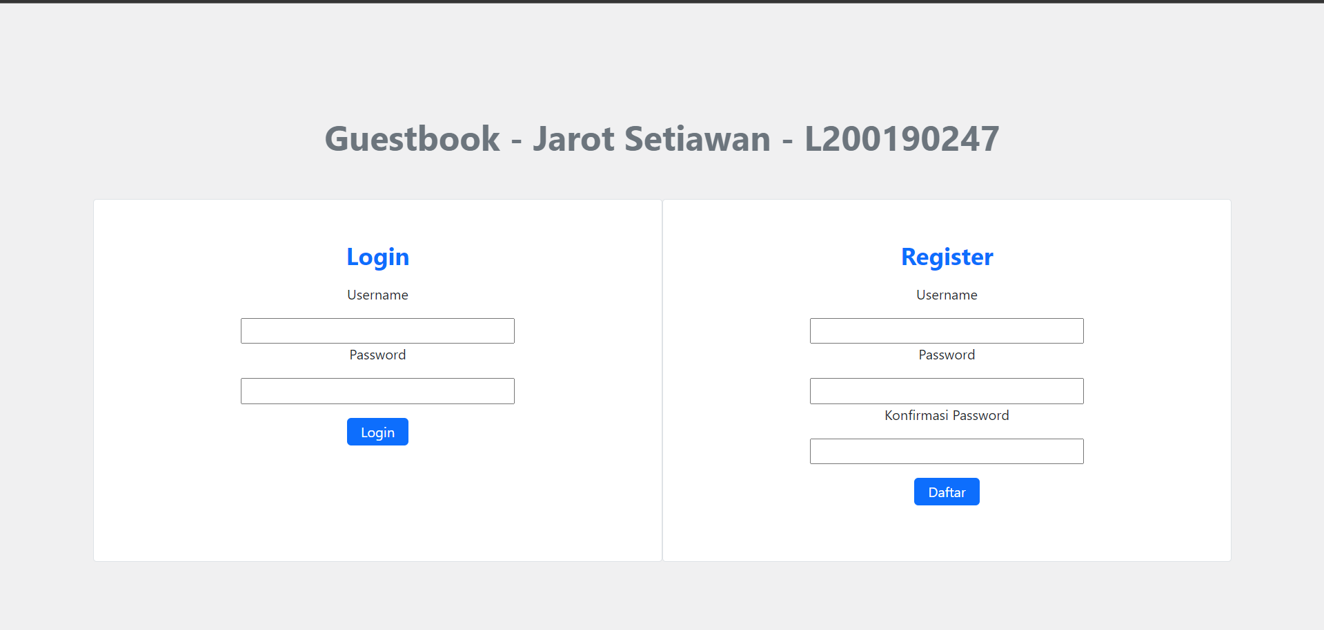

1. **Tampilan**

* **Admin**

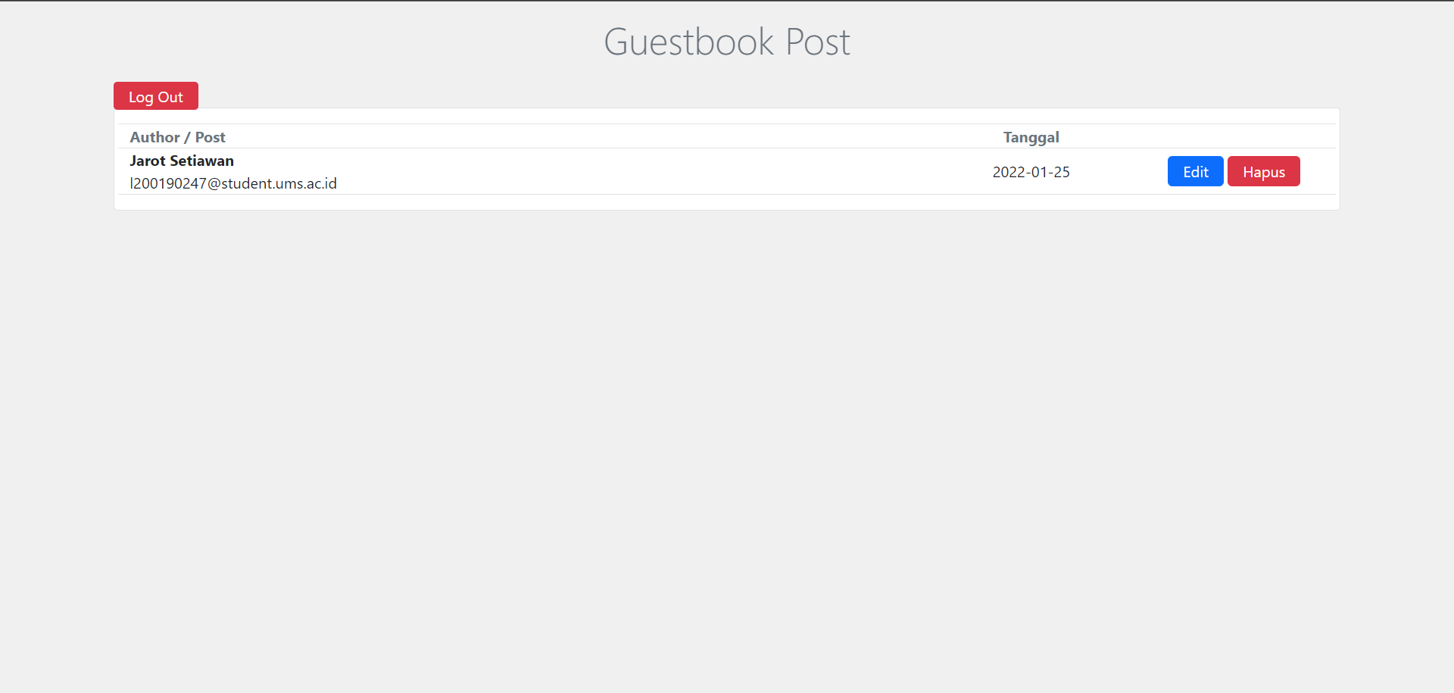

* **User**

